**Databases Assignment**

**Group Number: A13-G5**

**Tutor Name: Anthony Kleerekoper**

**Tanvir Alam Syed (21326844)**

**Hamza Sajid Bashir Akhtar (19007714)**

**Arham Ahmed Iram (21348835)**

**Muhammad Qasim (21339542)**

**Ming Kun Wu (21351241)**

**Table of Contents**

Section 1: Executive Summary 3

Section 2: Database Design 7

4a - Top Down ERD 7

4b - Normalisation and Bottom Up ERD 8

4c - Merge of Top Down and Bottom Up ERD’s 10

Section 5: SQL Implementation 11

5a - Drop and Create Statements 11

5b - Insert & Select Statements 12

Section 7: Student Statements 14

Student A – Name and ID 14

Student B – Name and ID 14

Student C – Name and ID 14

Student D – Name and ID 14

Appendix A: Individual ERD Attempts 16

Appendix B: Logbook 17

Appendix C: Full SQL Code 18

# Section 1 - Executive Summary

The purpose of the report is to demonstrate the process of creating a database when given a scenario to follow. The report also showcases the ERD’s as well as a SQL database based off a context. The content is a business called Mike’s Motorboats which is a business that hires out boats to people, they also work in the maintenance, acquisition, and accessories field when it comes to boats. The problem shown in the context with the business is that the organization of their data is poor, a lot of their data relies on writing down notes or in some cases data is lost due to them not being able to efficiently store it. This report tackles this issue, it firstly looks at creating ERD’s based on the context, a top down and bottom up ERD. Then a design combining both is made, with that the report shifts its focus onto the SQL database, this is segregated into the INSERT statements and the SELECT statements. The report then displays the entire code so the reader can view the entirety of the code if they wish.

# Section 2: Database Design

## 2a - Top Down ERD

The group began by looking at the context and coming to a general conclusion in regard to what entities should be created as well as what their attributes could be. We internally assigned each other to make an ERD each to get a further understanding of the task. Our attempts have been recorded in this file. One assumption we made is that when someone makes an enquiry, they become a customer within the database as their details are taken in. Another assumption we made is that we will not include the penalty fee per boat, we’d assume the business will either charge the same penalty fee per boat (removing the need to store the information per boat) or this information is given to the employees of the business in person.

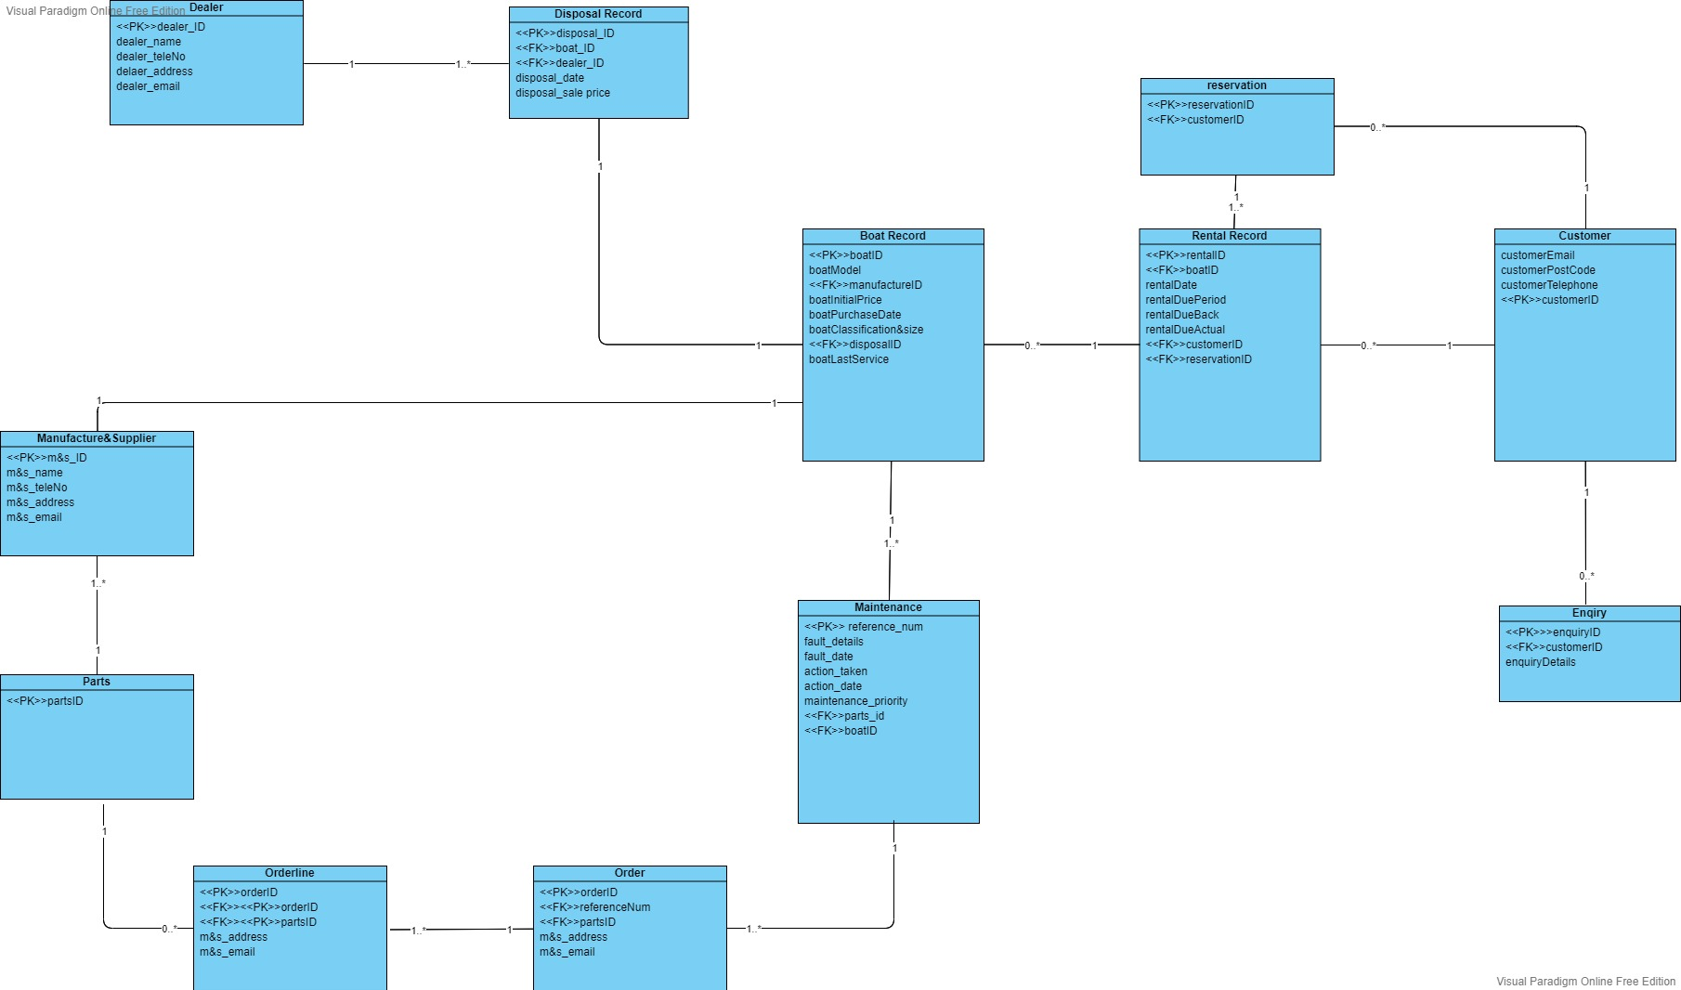

## 2b - Bottom Up ERD

**Boat Record Normalisation**

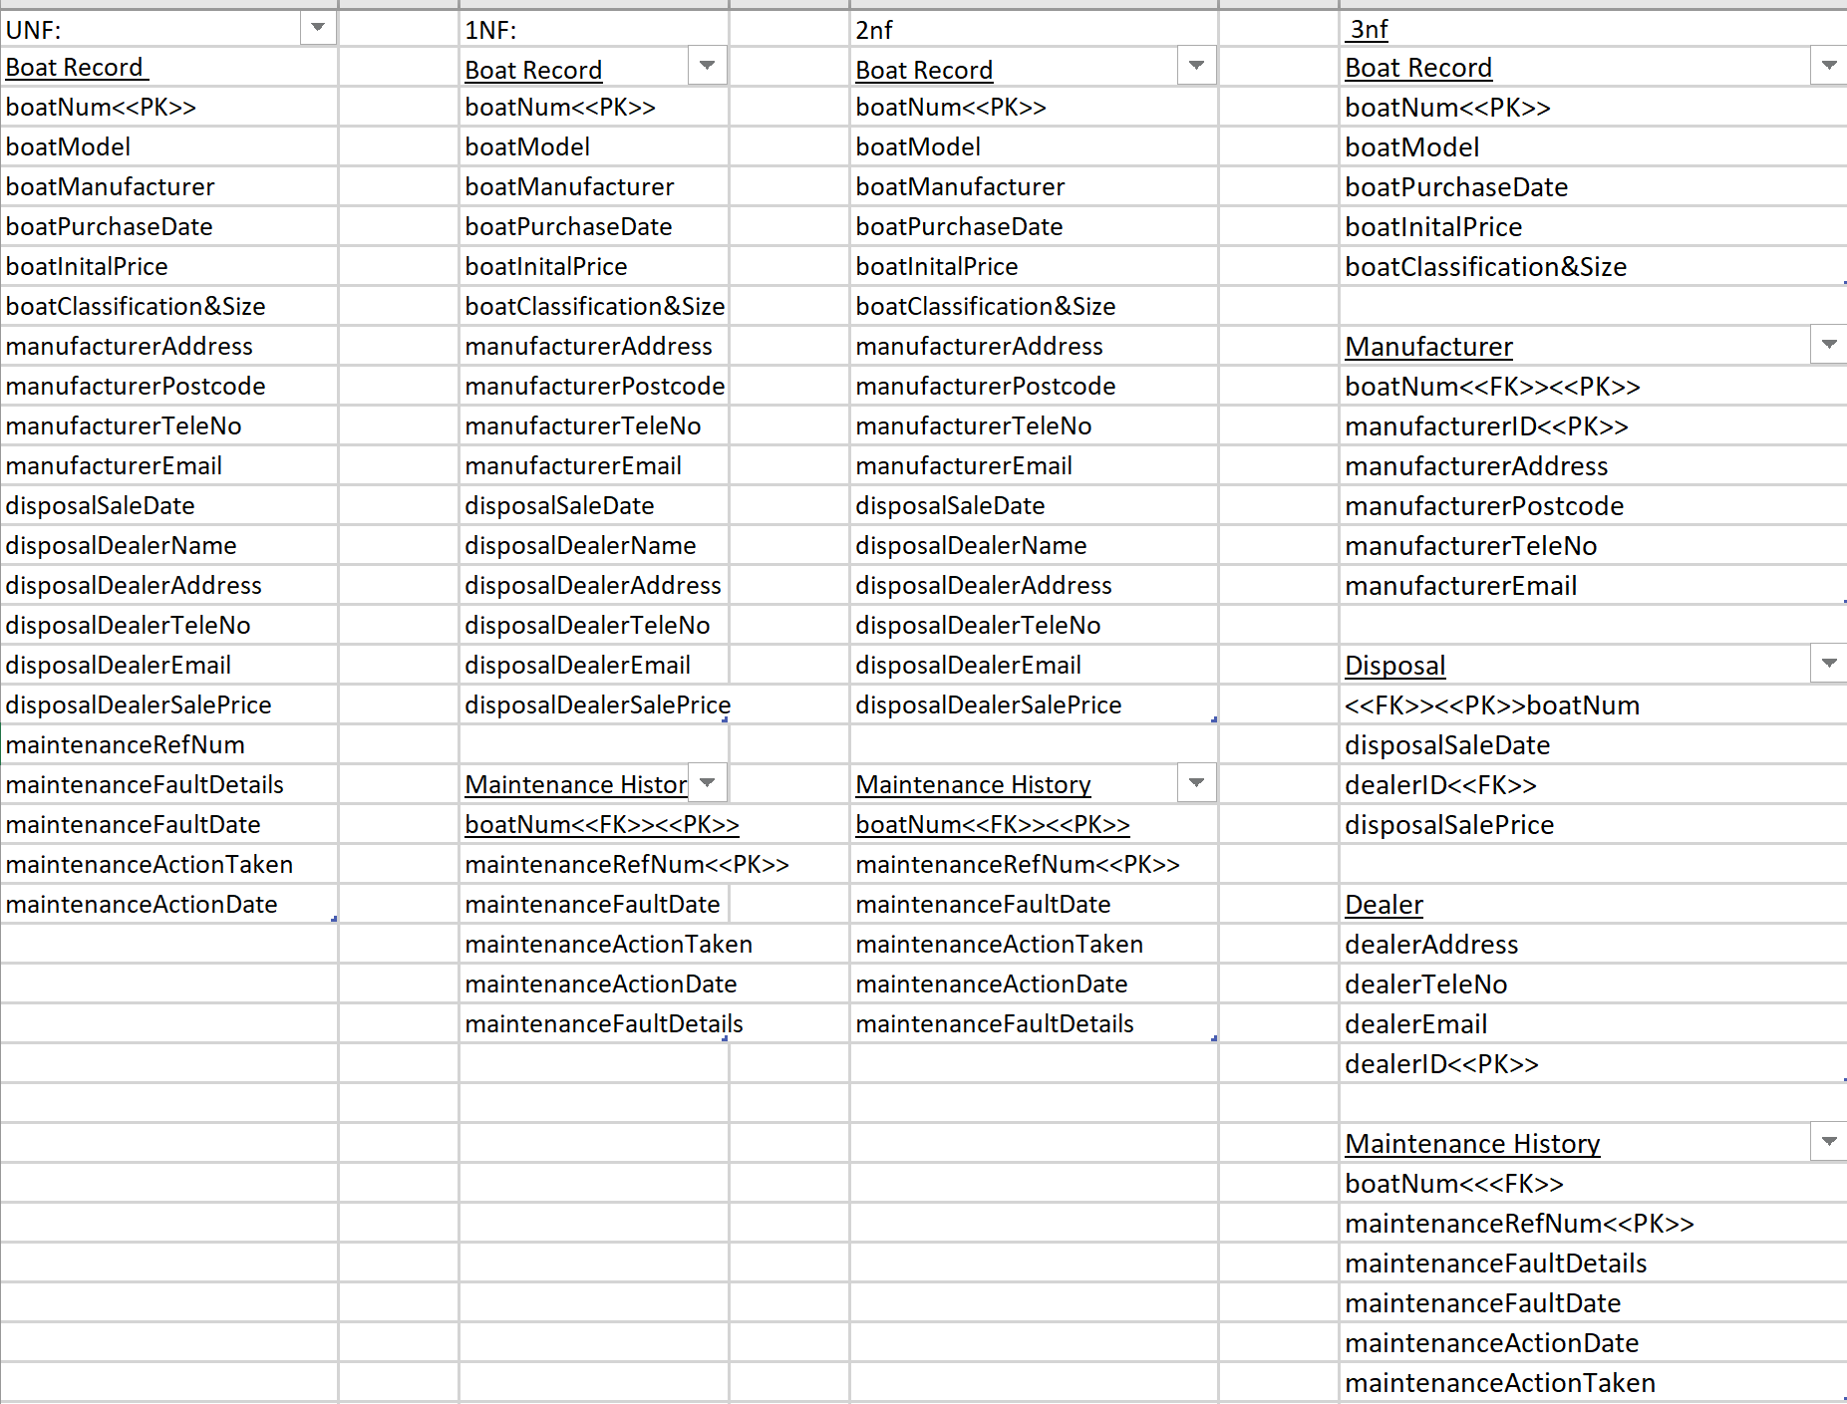

**Merged 3NFs from Normalisations and Bottom Up Data Model**

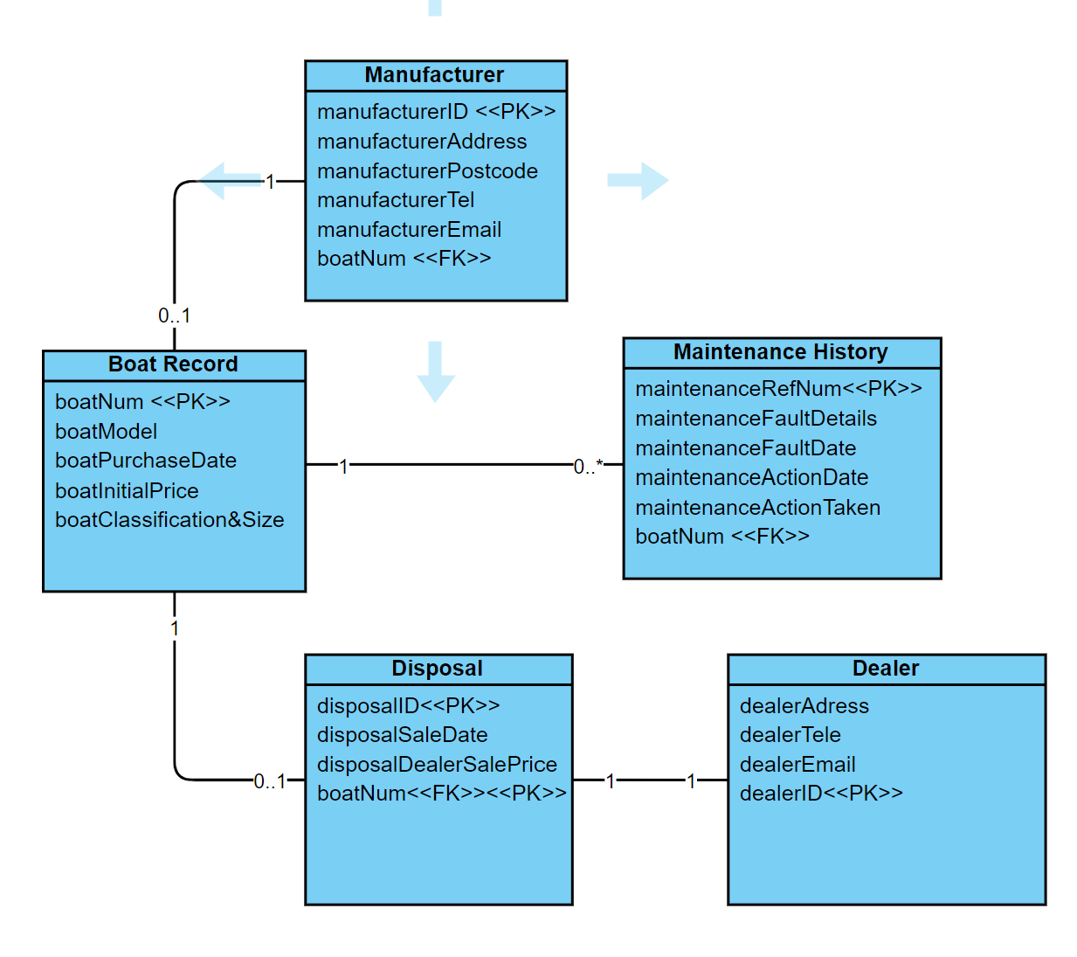

## 2c - Merge of Top Down and Bottom Up ERD’s

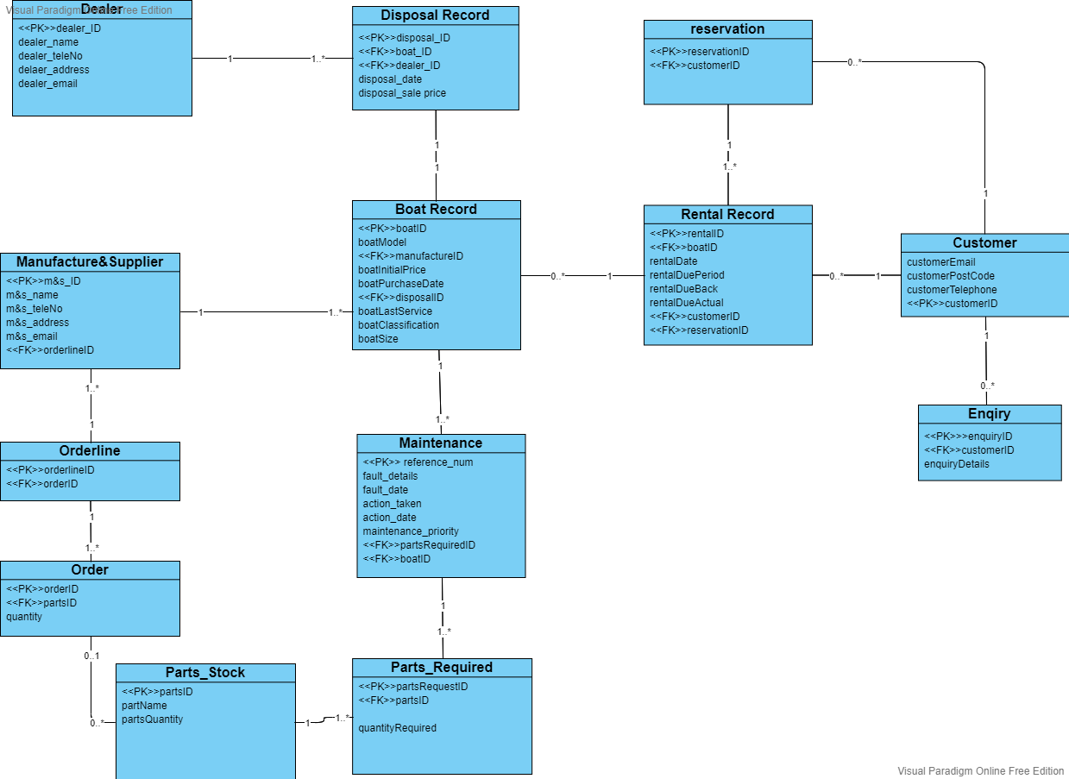

# Section 3: SQL Implementation

## 3a - Drop and Create Statements

CREATE TABLE Customer (

customerID int AUTO_INCREMENT,

customerFirstName varchar(50),

customerLastName varchar(50),

customerEmail varchar(50),

customerPostCode char(8),

customerTelephone varchar(20),

CONSTRAINT PRIMARY KEY (customerID) );

DROP TABLE Customer;

CREATE TABLE Customer (

customerID int AUTO_INCREMENT,

customerFirstName varchar(50),

customerLastName varchar(50),

customerEmail varchar(50),

customerPostCode char(8),

customerTelephone varchar(20),

CONSTRAINT PRIMARY KEY (customerID) );

CREATE TABLE Enquiry (

enquiryID int AUTO_INCREMENT,

customerID int,

enquiryDetails LONGTEXT,

CONSTRAINT PRIMARY KEY (enquiryID),

FOREIGN KEY (customerID) REFERENCES Customer(customerID) );

CREATE TABLE Reservation(

reservationID INT PRIMARY KEY,

customerID INT,

reservsationStatus varchar(20),

CONSTRAINT customerID_FK FOREIGN KEY (customerID) REFERENCES Customer (customerID));

CREATE TABLE Rental_Record(

rentalID INT PRIMARY KEY,

boatID VARCHAR(25),

rentalDate DATE,

rentalDuePeriod varchar(10),

rentalDueBack DATE,

rentalDueBackActual DATE,

rentalTotalPrice DECIMAL(5,2),

customerID INT,

reservationID INT,

CONSTRAINT reservationID_FK FOREIGN KEY (reservationID) REFERENCES Reservation (reservationID),

CONSTRAINT customerID_FKFK FOREIGN KEY (customerID) REFERENCES Customer (customerID));

CREATE TABLE Dealer (

dealerID INT PRIMARY KEY AUTO_INCREMENT,

dealerName VARCHAR(50),

dealerTeleNo VARCHAR(20),

dealerAddress VARCHAR(100),

dealerEmail VARCHAR(50) );

CREATE TABLE ManufacturerAndSupplier(

mAnds_ID INT PRIMARY KEY AUTO_INCREMENT,

orderlineID_FK INT,

mAnds_name VARCHAR(50),

mAnds_teleNo VARCHAR(20),

mAnds_address VARCHAR(100),

mAnds_email VARCHAR(50));

CREATE TABLE Disposal_Record (

disposalID INT PRIMARY KEY AUTO_INCREMENT,

dealerID INT,

CONSTRAINT dealerID_FK FOREIGN KEY (dealerID) REFERENCES Dealer(dealerID),

disposalDate DATE,

disposalSalePrice DECIMAL(10,2) );

CREATE TABLE Boat_Record ( boatID INT PRIMARY KEY AUTO_INCREMENT,

mAnds_ID INT,

CONSTRAINT manufactureID_FK FOREIGN KEY (mAnds_ID) REFERENCES ManufacturerAndSupplier(mAnds_ID),

disposalID INT,

CONSTRAINT disposal_ID_FK FOREIGN KEY (disposalID) REFERENCES Disposal_Record(disposalID),

boatInitialPrice DECIMAL(10,2),

boatPurchaseDate Date,

boatLastService DATE,

boatClassification VARCHAR(30),

boatSize VARCHAR(20),

boatModel VARCHAR(20));

CREATE TABLE Parts_Stock(

partsID INT PRIMARY KEY AUTO_INCREMENT,

partName VARCHAR(50),

partsQuantity INT );

CREATE TABLE Parts_Required(

partsRequestID INT AUTO_INCREMENT PRIMARY KEY,

partQuantity INT,

quantityRequired INT,

partsID INT,

CONSTRAINT partsID_FK FOREIGN KEY (partsID) REFERENCES Parts_Stock(partsID) );

CREATE TABLE Maintenance(

referanceNum INT AUTO_INCREMENT PRIMARY KEY,

faultDetails LONGTEXT,

faultDate DATE,

actionTaken LONGTEXT,

actionDate DATE,

maintenance_priority VARCHAR(50),

partsRequiredID INT,

boatID INT,

CONSTRAINT FK_partsRequiredID FOREIGN KEY (partsRequiredID) REFERENCES Parts_Required(partsRequestID),

CONSTRAINT FK_boatID FOREIGN KEY (boatID) REFERENCES Boat_Record(boatID) );

CREATE TABLE Orderr(

orderID INT PRIMARY KEY AUTO_INCREMENT,

quantity INT,

partsID INT,

CONSTRAINT partsID_FKFK FOREIGN KEY (partsID) REFERENCES Parts_Stock(partsID) );

CREATE TABLE Orderline(

orderlineID INT PRIMARY KEY AUTO_INCREMENT,

orderID INT,

CONSTRAINT orderID_FK FOREIGN KEY (orderID) REFERENCES Orderr(orderID) );

ALTER TABLE ManufacturerAndSupplier ADD CONSTRAINT orderlineID_FKFK FOREIGN KEY (orderlineID_FK) REFERENCES Orderline(orderlineID);

## 3b - Insert Statements

INSERT INTO Customer(customerFirstName, customerLastName, customerEmail, customerPostCode, customerTelephone) #Appendix D - List of customers

VALUES

('Dion','Brodnecke','dbroes1d@who.int',null,'07174826351'),

('Scarlett','Galley','scargr1c@imgur.com',null,'03260476982'),

('Sissy','Gadson','sgadson1b@ucoz.com',null,'04924556740'),

('Tabby','Minichi','minitabc@imgur.com',null,'07795213673'),

('Nellie','Greenmon','nelliegreen12@patch.com',null,'03816078215'),

('Hanny','Marsters','hmarsters@netlog.com',null,'07075576685'),

('Oswell','Aspinell','OsAspinell@digg.com',null,'09931348133'),

('Florance','Baston','FloBar@dirtg.com',null,'07315082134'),

('Candice','Tumilson','canditum15@bloomberg.com',null,'01639824657'),

('Clair','Bavin','clairBav@sprog.it',null,'06245985897'),

('Muhammad', 'Qasim','kasim@gmail.com',null,'09987670223'), #Tuples data for this table starts here

('Harry','Doe','john@gmail.com',null,'0876123881'),

('Poppy','Sissons','poppy@gmail.com',null,'08873487112'),

('John','William', 'johnwill@gmail.com', null, '07123231313'),

('Ken','Harber', 'kenny@gmail.com', null, '07314312312');

#Appendix D - List of Manufacturers

INSERT INTO ManufacturerAndSupplier(mAnds_name,mAnds_teleNo,mAnds_address,mAnds_email)

VALUES('SuperBoat', '01772459666', 'Unit 7 Centurion Court, Leyland, LE10 2DJ', 'admin@superboat.co.uk'),

('Explorer Boats UK','01704807654','Meadow Lane, Burscough, BU56 8GH','admin@explorerboats.co.uk'),

('The Northwich Boat Company', '01270160160', 'Unit 1 Kings Lock Boatyard Booth Lane, Middlewich, MW67 7GY', 'admin@northwichboats.co.uk'),

('Collingwood Boat Builders', '01513742985', '29 Townsend Street, Collingwood, CL27 2DU', 'admin@collingwoodboats.co.uk'),

('Elton Moss Boat Builders', '01270760160', 'Unit 4 Kings Lock Boatyard Booth Lane, Middlewich, MW63 8TY', 'admin@eltonmossboats.co.uk'),

('Aintree Boat Company Ltd ', '01515239000', 'Brookfield Drive, Liverpool, L1 6GU ', 'admin@aintreeboats.co.uk'),

('Braidbar Boats Ltd', '01625873471', 'Lord Vernons Wharf Lyme Road Higher, Poynton, PY12 9TS', 'admin@braidbarboats.co.uk'),

('Bourne Boat Builders Ltd', '01785714692', 'Teddesley Road, Penkridge, PE8 7SU', 'admin@bourneboats.co.uk'),

('Stoke on Trent Boat Building Co Ltd', '01782813831', 'Longport Wharf Station Street, Stoke-on-Trent, ST6 9GU', 'admin@stokeboats.co.uk'),

('MGM Boats Narrowboat Builders', '01162640009', '27 Mill Lane, Leicester, LE6 9FY', 'admin@mgmboats.co.uk'),

('Johns Super Boats','07768519221','50 Robin Hood Lane, Winnersh",RG41 5NQ','john@superboats.com'), #Tuples data for this table starts here

('Michelle Boats For You','08876123881','210 Albert Road, Leyton",E10 6PD','michelle@boatsforyou.com'),

('Barrys Best Boats','08876129882','1 Stocks Hill, Manton",LE15 8SY','barry@bestboats.com'),

("MR Bean Boats CO Ltd", "07396719638", "22 Stoke Gardens, Ellesmere Port,CH65 0DR", "beanco@gmail.com"),

("Mirage Motorboats Co Ltd","07292628911", "Windyridge, 12 Bath Road, Ashcott,TA7 9QU", "mmmotorboats@gmail.com");

#Appendix D - List of dealers

INSERT INTO Dealer(dealerName, dealerTeleNo, dealerAddress, dealerEmail)

VALUES("Dalis Vannoort", '07574137463', "77 A828, Appin, AP7 6GU", "dvannoort0@salon.com"),

("Joe's Junk", '07365534221', "15 Back Lane, Buxton, BX7 5FY J", "JoesJunk@zdnet.com"),

("Hoebart Kubera", '07874051869', "4 Finedon House, Marine Parade, Littlestone, LS4 6GU", "hkubera2@who.int"),

("Eva Iacomettii", '07880072148', "8 9 Hartlands, Onslow Road, Newent, NW5 8TU", "eiacomettii3@admin.ch"),

("Alley Pate", '07822040557', "07610 Arizona Alley, A67 8GU", "apate4@gnu.org"),

('Korrie Legge', '07380018233', '1076 Evesham Road, Astwood Bank, DT5 8JO', 'klegge5@reference.com'),

('Minne Hinkens' ,'07978390430', '53 Balby Road, Balby, B7 8HK' ,'mhinkens6@smh.com.au'),

('Inigo MacAllaster', '07893419552' ,'1910 Farwell Plaza, G56 9FT', 'imacallaster7@blogspot.com'),

('Linell Skeeles', '07532931207', '57 Great Russell Street, London, NW1 8TU', 'lskeeles8@goo.gl'),

('Sioux Drogan', '07417098738' ,'75 Thomas Parsons Square, Ely, EL6 9GU' ,'sdrogan9@dropbox.com'),

('Curtis Boats','09987130992','2 Shawhurst Croft, Hollywood",B47 5PB','curtisboats@gmail.com'), #Tuples data for this table starts here

('Poppy Parts','09982134882', '10 Ranelagh Drive, Sheffield",S11 9HE','poppy@boatparts.com'),

('Craig Shone','07786238119','21 Borrowdale Avenue, Dunstable",LU6 3PG','craigshone@gmail.com'),

("Charrade junk", "07494623823", "9 Woodgates Close, North Ferriby,HU14 3JS", "charradejunk22@gmail.com"),

("Expired Stuff", "07323742812", "4 Durrington Road, Bournemouth,BH7 6QA", "Expiredboats@gmail.com");

INSERT INTO Disposal_Record (dealerID,disposalDate,disposalSalePrice)

VALUES( 1,'2020-11-30',1500.00);

SELECT *

FROM Disposal_Record;

INSERT INTO Boat_Record(mAnds_ID,disposalID,boatInitialPrice ,boatPurchaseDate , boatLastService, boatClassification,boatSize,boatModel )

VALUES(1,1,3910.00,'2010-11-22','2020-10-22','motorboat','standard', "Explorer");

SELECT *

FROM Boat_Record;

INSERT INTO Maintenance(faultDetails, faultDate, actionTaken, actionDate, boatID)

VALUES("Chipped propeller","2015-02-15",'Replaced propeller','2015-02-27',1),

("Bilge pumps gone","2015-07-10",'New bilge pumps', '2015-08-27',1),

(null,null,"New head pumps",'2015-08-15',1),

(null,null,"Normal service",'2016-03-20',1),

('Cutless bearing worn through','2016-12-02', "Fit new bearing", "2017-01-27",1);

SELECT *

FROM Maintenance

WHERE boatID = 1;

INSERT INTO Rental_Record(rentalID, rentalDate, rentalDuePeriod, rentalDueBack, rentalTotalPrice ,rentalDueBackActual)

VALUES(4734,'2019-05-02',"HD",'2019-05-02',125.00,'2019-05-02'),

(4745,'2019-05-03',"HD",'2019-05-03',125.00,'2019-05-03'),

(4812,'2019-05-04',"2D",'2019-05-05',400.00,'2019-05-06'),

(4875,'2019-05-06',"FD",'2019-05-06',200.00,'2019-05-06'),

(4976,'2020-05-01','HD','2020-05-01',125.00,'2020-05-01'), #Tuples data for this table starts here

(4977,'2019-03-02','FD','2019-03-02',200.00,'2019-03-02'),

(4910, '2019-06-06','HD', '2019-06-06',125.00,'2019-06-06'),

(5910, '2020-07-10', 'FD', '2020-07-10', 200.00, '2020-07-10'),

(5911, '2020-07-15', 'HD', '2020-07-15', 125.00, '2020-07-15');

SELECT *

FROM Rental_Record;

INSERT INTO Disposal_Record (dealerID,disposalDate,disposalSalePrice)

VALUES(2,'2019-10-10',1500.00);

SELECT *

FROM Disposal_Record;

INSERT INTO Boat_Record(mAnds_ID,disposalID,boatInitialPrice ,boatPurchaseDate , boatLastService, boatClassification,boatSize)

VALUES(2,2,3240.00,'2015-10-12','2020-01-27','Sail Boat','large');

SELECT *

FROM Boat_Record;

INSERT INTO Boat_Record(mAnds_ID,boatInitialPrice ,boatPurchaseDate , boatLastService, boatClassification,boatSize,boatModel)

VALUES(2,3840,"2009-10-12","2019-10-08","Sail Boat","Very Large","TurboSail"),

(2,3240,"2015-10-15","2020-10-12", "Sail Boat", "Large","MasterSail"),

(3,2040,"2015-11-12","2020-10-14","Sail Boat", "Small", "SmallSailor"),

(3,2040,"2015-11-12","2020-10-14","Sail Boat", "Small", "SmallSailor"),

(5,5440,"2015-01-14","2020-10-15", "Motorboat", "Large", "Grande"),

(5,5440,"2015-01-14","2020-09-13", "Motorboat", "Large", "Grande"),

(2, 5440.00, "2015-1-14", "2020-09-13", "MotorBoat","Standard", "Turbo Mid"),

(3, 440.00, "2015-1-12", "2020-08-10", "RowingBoat","Large", "RowStream"),

(4, 320.00, "2015-1-12", "2020-09-22", "RowingBoat","Standard", "RowerX"),

(1, 3320.00, "2016-1-10", "2020-03-03", "SailBoat","Large", "Explorer"),

(1, 3320, "2016-1-10", "2020-4-3", "Sail Boat", "Standard", "Navigator"),

(2, 4440, "2018-2-14", "2020-9-14", "Motor Boat", "Standard", "Turbo Mid"),

(2, 4440, "2018-2-14", "2020-9-13", "Motor Boat", "Standard", "Turbo Mid"),

(7, 5440, "2018-1-14", "2019-10-14", "Motor Boat", "Large", "MasterBlaster"),

(8, 340, "2018-1-10", "2020-10-2", "Rowing Boat", "Large", "HappyRower"),

(8, 340, "2018-1-10", "2020-10-2", "Rowing Boat", "Small", "HappyRower"),

(3, 640, "2017-1-9", "2020-10-7", "Rowing Boat", "Very Large", "Streamer"),

(4,650 ,'2019-01-19' , '2020-09-12', 'Rowing boat','Very Large','Great Row'),

(7,7440 ,'2018-01-14' , '2020-08-07', 'MotorBoat','Very Large','SuperBlaster'),

(6,340 ,'2017-01-09' , '2020-10-04', 'Rowing boat','Standard','Lizard'),

(5,5440 ,'2018-02-14' , '2020-09-13', 'MotorBoat','Large','Grande'),

(2,3240 ,'2015-10-12' , '2020-01-27', 'Sail boat','Large','MasterSail'),

(3,4000,'2016-10-13','2020-02-20','Rowing Boat','Very Large','Turbo Mid'), #Tuples data for this table starts here

(5,56790 ,'2018-06-12' , '2020-01-27', 'Motor boat','Standard','Grande'),

(5,5440.00,'2017-02-04', '2020-10-10', 'Motorboat','Large','TurboMix'),

(7, 5570.00, "2017-7-7", "2020-07-7", "Motorboat","Very Large", "RowerX"),

(4,3200, '2017-10-20', '2017-12-10','Rowing Boat','Large', 'Great Row');

INSERT INTO Maintenance(faultDetails, faultDate, actionTaken, actionDate, boatID)

VALUES("Damaged mast","2016-04-17",'Repair mast','2016-04-27',3),

("Bent Forestay","2017-07-10",'Replace Forestay', '2017-08-22',3),

("Shot Boom","2018-05-18","Replace Boom",'2018-06-06',3),

("Rudderstock Chipped","2019-07-07","Repair Rudderstock",'2019-07-08',3),

(null,null, "Normal Service", "2020-01-27",3),

("Rudderblade busted", "2020-10-19", null, null,3),

('Snapped Forestay','2019-05-20',null,null,2), #Tuples data for this table starts here

(null,null, "Normal Service", "2020-01-27",2),

("Engine Failure","2019-07-07","Repair Engine",'2019-07-08',2),

(null,null, 'Normal Service','2020-05-12',2),

('Shot Boom', '2020-05-15','Replace Boom', '2020-05-20', 2);

SELECT *

FROM Maintenance

WHERE boatID = 2;

SELECT *

FROM Maintenance

WHERE boatID = 3;

SELECT *

FROM Boat_Record;

INSERT INTO Reservation (customerID,ReservationID)

VALUES(1,5344),

(2,5345),

(9,5347),

(4,5346),

(7,5349),

(6,5348),

(2,5350),

(5,5352),

(5,5353),

(9,5354),

(2,5351),

(8,5364),

(9,5355),

(1,5356),

(6,5357),

(7,5385),

(10,5366),

(4,5360),

(8,5361),

(10,5359),

(3,5362),

(3,5365),

(1,5363),

(1,5342),

(4,5341),

(2,5343),

(3,5544),#Tuples data for this table starts here

(4,5545),

(5,5546),

(6,5547),

(7,5548);

INSERT INTO Rental_Record(rentalID, customerID,rentalDate,boatID,rentalDuePeriod,rentalTotalPrice,reservationID)

VALUES(4876,1,"2020-10-20",9, "1D", 280.00, 5344),

(4877,2,'2020-10-20', 16, '1D', 220, 5345),

(4878,9,'2020-10-20',7,"1D",240,5347),

(4879,4,'2020-10-20',6,"1D",240,5346),

(4880,7,'2020-10-20',9,"1D",140,5349),

(4881,6, "2020-10-20", 15, "1D", 240.00, 5348),

(4882,2, "2020-10-20", 9, "1D", 180.00, 5350),

(4883,5, "2020-10-20", 16, "1D", 110.00, 5352),

(4884,5, "2020-10-20", 17, "1D", 110.00, 5353),

(4885,9, "2020-10-20", 14, "2D", 400.00, 5354),

(4886,2, "2020-12-20", 11, "1D", 180.00, 5351),

(4887,8, "2020-12-20", 4, "1D", 110.00, 5364),

(4888,9, "2020-12-20", 13, "2D", 400.00, 5355),

(4889,1, "2020-12-20", 8, "1D", 200.00, 5356),

(4890,6, "2020-12-20", 1, "1D", 200.00, 5357),

(4891,7, '2020-10-20', 10, '1D', 120.00, 5385),

(4892,10, '2020-10-20', 21, '1/2D', 80.00, 5366),

(4893,4, '2020-10-20', 20, '1D', 280.00, 5360),

(4894,8, '2020-10-20', 2, '1D', 240.00, 5361),

(4895,10, '2020-10-20', NULL, '1D', 160.00, 5359),

(4896,3,'2020-10-20',NULL,'1D',100,5362),

(4897,3,'2020-10-20',NULL,'1D',120,5365),

(4898,3,'2020-10-20',NULL,'1D',100,5363),

(4899,1,'2020-04-27',16,'1D',180,5342),

(4900,4,'2019-10-20',6,'1D',240,5341),

(4901,2,'2019-12-09',6,'1D',240,5343),

(4092,3,'2020-02-02',5,'1D',100.00,5544), #Tuples data for this table starts here

(5100,7,'2020-12-19', 12,'1D', 200.00, 5548),

(4903,5,'2020-09-10',3,'1D',200.00,5546),

(4969,4,'2021-12-09',6,'1D',100,5545),

(4970,6,'2017-07-07',7,'2D',777.00,5547);

SELECT *

FROM Rental_Record;

## 3c – Screenshots of Insert Data

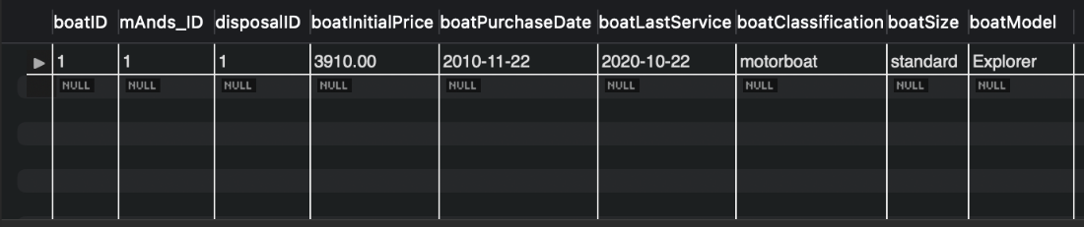

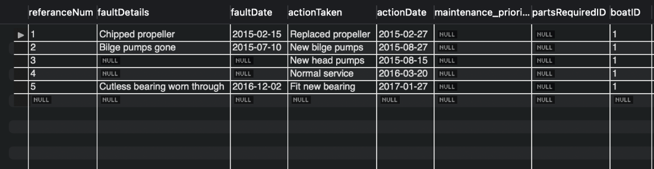

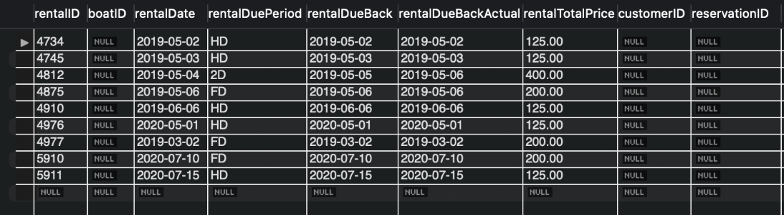

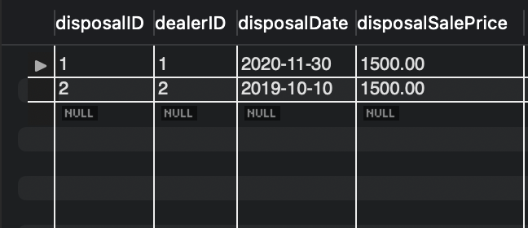

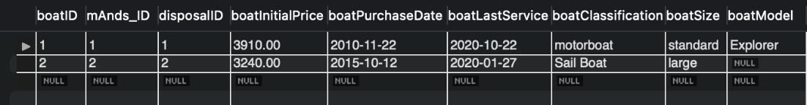

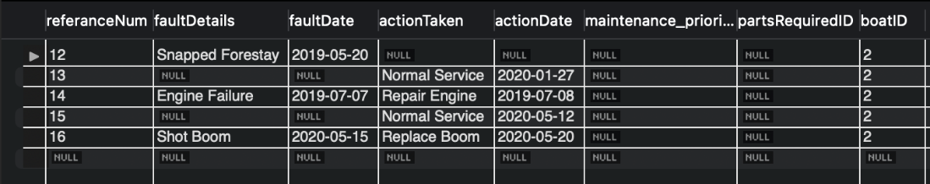

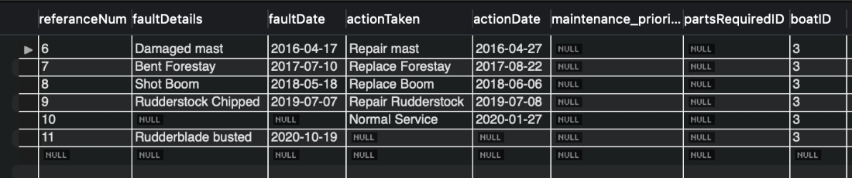

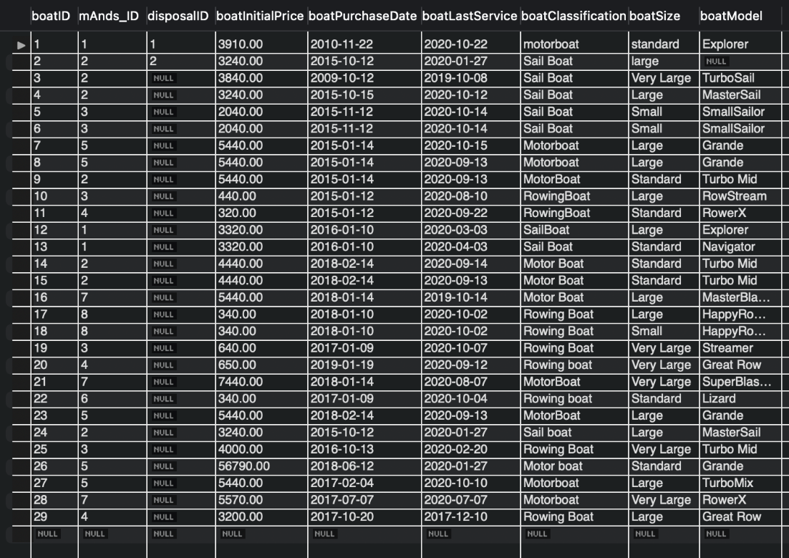

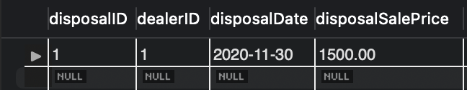

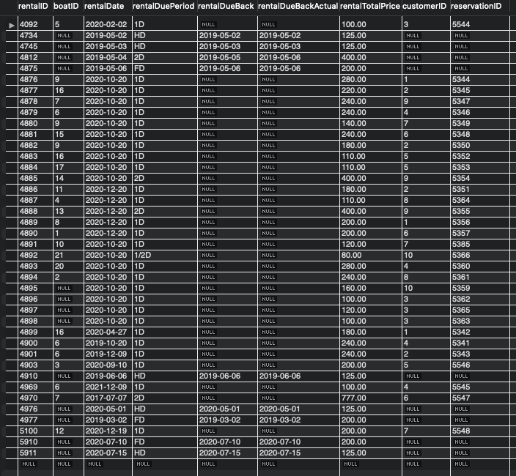

# Section 4: Student Statements

## Student A – Tanvir Alam Syed |21326844

During this project, I have learnt how to use diverse types of SQL commands to manipulate databases. I also learnt how to correctly create ERDs via the Top-Down and Bottom-up approach. In terms of teamwork, I learnt that decomposing problems into subsections were the easiest way to tackle this project and allowed the process of transitioning from theory to practical to happen smoothly.

## Student B – Muhammad Qasim | 21339542

Throughout this group project I have developed an understanding of how databases work, this was done through creating the ERD’s as well as creating the SQL database. With the ERD work, utilising the top-down and bottom-up approach allowed to visually understand how the relationships between entities work correctly. With that understanding, I was able to work with my group to convert the ERD into a MYSQL database which was a process in which I learnt more about ensuring the relationships between entities is done correctly, the error log was useful for this.

## Student C – Arham Ahmed Iram |21348835

In this Project I have learnt how to create a database. By creating our top-down and bottom-up ERD’s I was able to understand how Primary and Foreign Keys worked. Also, when creating our final ERD in MySQL Workbench, I learned how to use different statement. Also, working as a team showed me that any sort of idea can be helpful to solve a problem, and that communication is key to success.

## Student D – Ming Kun Wu | 21351241 In this project, I have learned about Databases and SQL. With how relationships work when creating ERDs. I have also learned to use using top-down, bottom-up, and normalization to further improve the ERD's. Exploring SQL has allowed me to understand how to create a Database, finding the easiest ways to create a database while still allowing it to be efficient.

## Overall, this has taught me now to work effectively in a group.

**Student E – Hamza Sajid Bashir Akhtar | 19007714**

In this group project, I learnt about database structure and the way its initiated, organised and interlinked using Entity Relationship diagrams. I learnt how the Entities are interlinked with each other and how the information flows through the whole structure. I also learnt about creating a database using “mySql”. Creating tables, linking them, inserting values in them and then altering them for any changes to be made. I learnt how to work efficiently with the team from designing the ERDs to Implementing them into a database using “mySql”.

# Appendix A: Individual ERD Attempts

**Tanvir Alam Syed (21326844)**

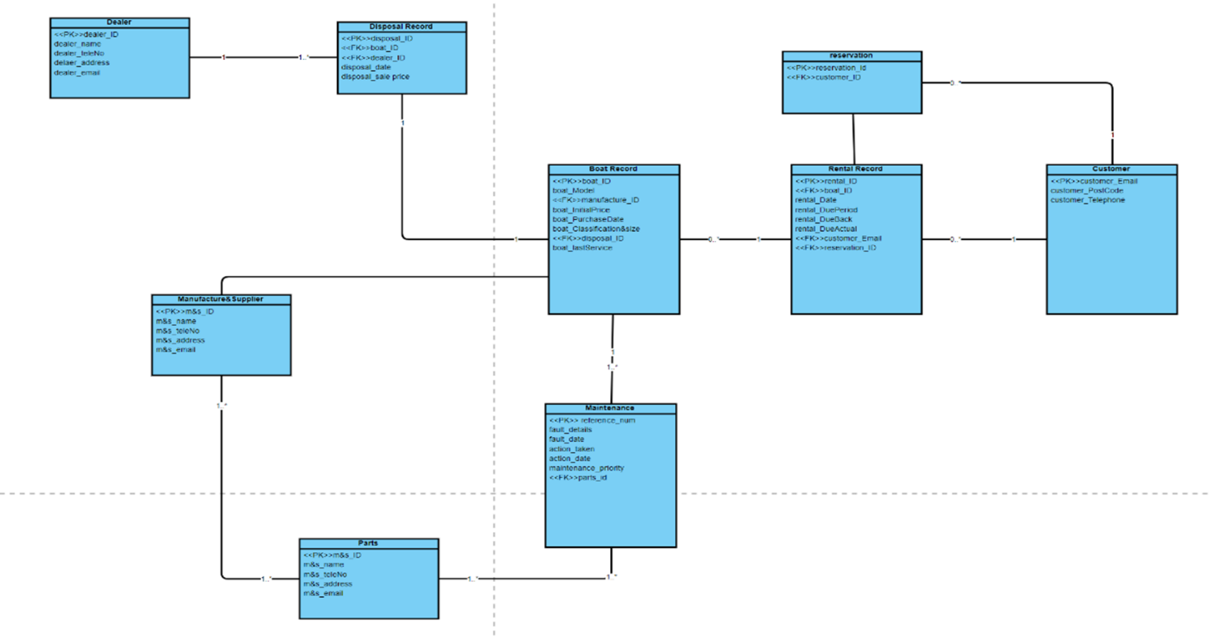

**Hamza Sajid Bashir Akhtar (19007714)**

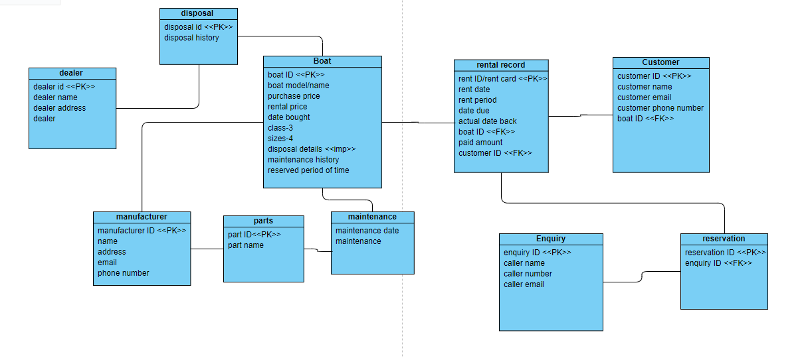

**Arham Ahmed Iram (21348835)**

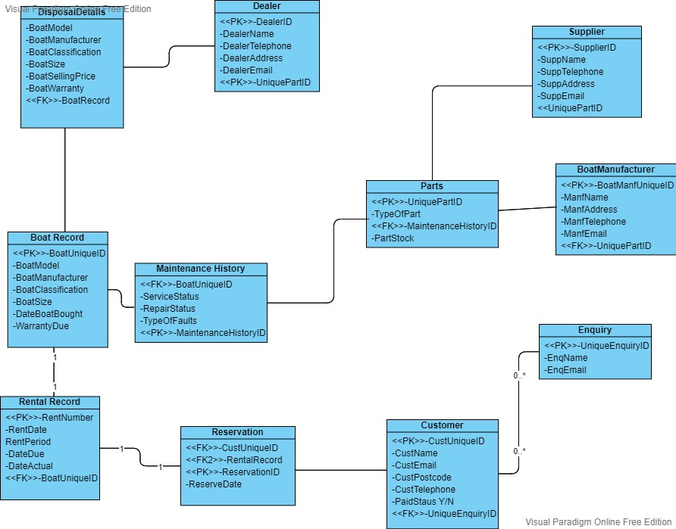

**Muhammad Qasim (21339542)**

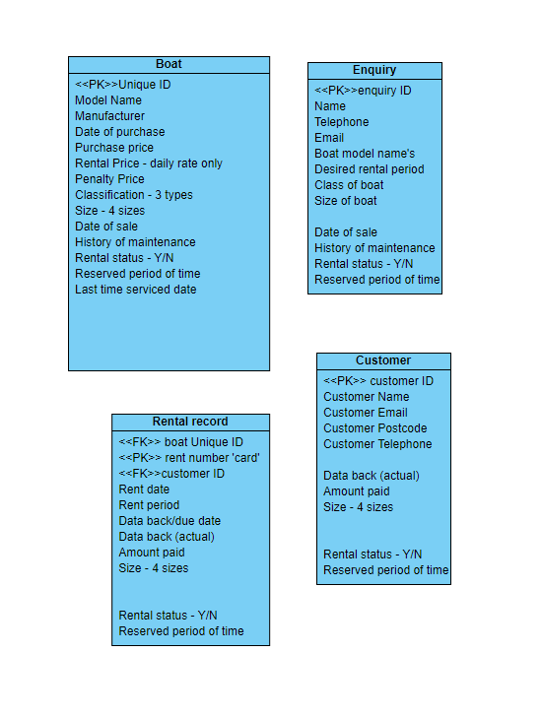

**Ming Kun Wu (21351241)**

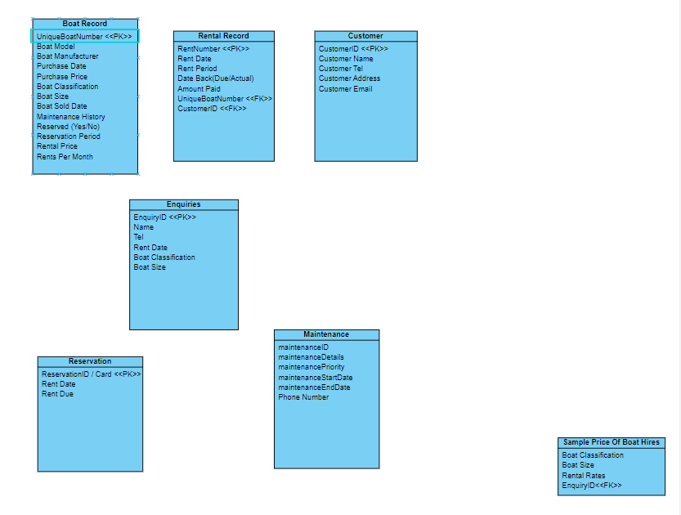

# Appendix B: Logbook

*Copy and paste all of your logbook entries here*

*Each logbook should clearly display the following:*

**Date: 26/1/22**

**Names of those present: Everyone**

**Names of those absent: none**

**What was discussed: In this meeting we decomposed the details and kept note as to which details are entities and which are attributes of the entities. We also had debate as to whether to keep the penalty fee of bringing rented boats late, without being added to overall fee**

**Discussion – debate about hiding penalty fees – hide fees ore keep them**

**Action plan: Everyone has been set to now attempt to create their own ERD and in the next meeting each present their diagram to then create a group ERD which will lead us to the next section**

**Date: 02/2/2022**

**Names of those present: Everyone**

**Names of those absent: none**

**What was discussed: We looked at everyone’s attempts of the ERD’s based on the discussion we had last week. Everyone made a suitable attempt at the ERD.**

**Notes:**

**- Add customer ID to be paired with the <<PK>>Customer Email.**

**- Disposal record change from "1" to "0..1"**

**- Does every single attribute need to be filled in with the database? Or can it be partial.**

**Discussion – After reviewing everyone’s ERD’s we have decided that we are going to create a full ERD using all our ideas the next time we meet in person as this meeting was conducted online.**

**Action plan: Prepare for the next meeting by reading the context once again to ensure we are ready for the meeting where we will draft up our tables.**

**Date: 03/02/2022**

**Names of those present: Everyone**

**Names of those absent: None**

**What was discussed: We drafted up the tables for the boat record normalisation, we then transferred them into Microsoft excel so we can put them into tables. We then took a screenshot to enter this file as evidence.**

**Notes:**

**Discussion – The discussion was surrounding the normalisation process of the boat record.**

**Action plan: The plan is to meet up next week to build the bottom up ERD so it can be implemented into our finalized ERD.**

**Date: 09/02/2022**

**Names of those present: Everyone**

**Names of those absent: None**

**What was discussed: We discussed what the final version of our group ERD will look like, we also created the bottom up ERD before merging the two.**

**Notes:**

**Discussion – The discussion was surrounding the finalisation of the merging of Top Down and Bottom Up diagrams.**

**Action plan: The plan is to meetup next week to start the SQL work.**

**Date: 16/02/2022**

**Names of those present: Everyone**

**Names of those absent: None**

**What was discussed: After getting some tutor feedback, we had to redesign our group ERD and we are going to take our new finalized version back to our tutor next week. Some other changes were made to the group ERD that we pointed out during this meetings discussion.**

**Notes:**

**Discussion – The discussion was surrounding the finalisation of our group ERD, we agreed that the next meeting is going to be dedicated to us starting the SQL work**

**Action plan: The plan is to meetup next week to start the SQL work and implement any further changes our tutor suggests next week.**

**Date: 23/02/2022**

**Names of those present: Everyone**

**Names of those absent: None**

**What was discussed: Given our ERD has been passed off by out tutor, we moved onto the SQL part of the task.**

**Notes: After combining the code together, we noticed some issues with the code so we are beginning to amend the issues.**

**Action plan: The plan is to meetup later this week to continue working on our SQL code.**

**Date: 25/02/2022**

**Names of those present: Everyone apart from Tanvir.**

**Names of those absent: Tanvir.**

**What was discussed: We discussed how to finish the creation of the tables within the database.**

**Notes: After debugging the issues with our SQL code, we managed to finish the creation of all tables with no errors as well as add our drop statement.**

**Action plan: The plan is to meetup next week to allocate the insert statement to different team members.**

**Date: 02/03/2022**

**Names of those present: Everyone.**

**Names of those absent: None.**

**What was discussed: We discussed how to combine details from different tables within our SQL code.**

**Notes: After debugging the issues with our SQL code, we continued to code the SQL code.**

**Action plan: The plan is to meetup later in the week and continue to insert data into the tables.**

**Date: 04/03/2022**

**Names of those present: Everyone.**

**Names of those absent: None.**

**What was discussed: We have been inserting data from the appendixes into our database and should be finishing up on the details soon.**

**Notes: Check for any errors within the code**

**Action plan: Take screen shots of the results and fill in details needed within the word document and then we are finished.**

**Date: 08/03/2022**

**Names of those present: Everyone.**

**Names of those absent: None.**

**What was discussed: We finalized our SQL code by adding the tuple data into our MYSQL database, we then submitted our report.**

**Notes:**

**Action plan:**

# Appendix C: Full SQL Code

CREATE TABLE Customer (

customerID int AUTO_INCREMENT,

customerFirstName varchar(50),

customerLastName varchar(50),

customerEmail varchar(50),

customerPostCode char(8),

customerTelephone varchar(20),

CONSTRAINT PRIMARY KEY (customerID) );

DROP TABLE Customer;

CREATE TABLE Customer (

customerID int AUTO_INCREMENT,

customerFirstName varchar(50),

customerLastName varchar(50),

customerEmail varchar(50),

customerPostCode char(8),

customerTelephone varchar(20),

CONSTRAINT PRIMARY KEY (customerID) );

CREATE TABLE Enquiry (

enquiryID int AUTO_INCREMENT,

customerID int,

enquiryDetails LONGTEXT,

CONSTRAINT PRIMARY KEY (enquiryID),

FOREIGN KEY (customerID) REFERENCES Customer(customerID) );

CREATE TABLE Reservation(

reservationID INT PRIMARY KEY,

customerID INT,

reservsationStatus varchar(20),

CONSTRAINT customerID_FK FOREIGN KEY (customerID) REFERENCES Customer (customerID));

CREATE TABLE Rental_Record(

rentalID INT PRIMARY KEY,

boatID VARCHAR(25),

rentalDate DATE,

rentalDuePeriod varchar(10),

rentalDueBack DATE,

rentalDueBackActual DATE,

rentalTotalPrice DECIMAL(5,2),

customerID INT,

reservationID INT,

CONSTRAINT reservationID_FK FOREIGN KEY (reservationID) REFERENCES Reservation (reservationID),

CONSTRAINT customerID_FKFK FOREIGN KEY (customerID) REFERENCES Customer (customerID));

CREATE TABLE Dealer (

dealerID INT PRIMARY KEY AUTO_INCREMENT,

dealerName VARCHAR(50),

dealerTeleNo VARCHAR(20),

dealerAddress VARCHAR(100),

dealerEmail VARCHAR(50) );

CREATE TABLE ManufacturerAndSupplier(

mAnds_ID INT PRIMARY KEY AUTO_INCREMENT,

orderlineID_FK INT,

mAnds_name VARCHAR(50),

mAnds_teleNo VARCHAR(20),

mAnds_address VARCHAR(100),

mAnds_email VARCHAR(50));

CREATE TABLE Disposal_Record (

disposalID INT PRIMARY KEY AUTO_INCREMENT,

dealerID INT,

CONSTRAINT dealerID_FK FOREIGN KEY (dealerID) REFERENCES Dealer(dealerID),

disposalDate DATE,

disposalSalePrice DECIMAL(10,2) );

CREATE TABLE Boat_Record ( boatID INT PRIMARY KEY AUTO_INCREMENT,

mAnds_ID INT,

CONSTRAINT manufactureID_FK FOREIGN KEY (mAnds_ID) REFERENCES ManufacturerAndSupplier(mAnds_ID),

disposalID INT,

CONSTRAINT disposal_ID_FK FOREIGN KEY (disposalID) REFERENCES Disposal_Record(disposalID),

boatInitialPrice DECIMAL(10,2),

boatPurchaseDate Date,

boatLastService DATE,

boatClassification VARCHAR(30),

boatSize VARCHAR(20),

boatModel VARCHAR(20));

CREATE TABLE Parts_Stock(

partsID INT PRIMARY KEY AUTO_INCREMENT,

partName VARCHAR(50),

partsQuantity INT );

CREATE TABLE Parts_Required(

partsRequestID INT AUTO_INCREMENT PRIMARY KEY,

partQuantity INT,

quantityRequired INT,

partsID INT,

CONSTRAINT partsID_FK FOREIGN KEY (partsID) REFERENCES Parts_Stock(partsID) );

CREATE TABLE Maintenance(

referanceNum INT AUTO_INCREMENT PRIMARY KEY,

faultDetails LONGTEXT,

faultDate DATE,

actionTaken LONGTEXT,

actionDate DATE,

maintenance_priority VARCHAR(50),

partsRequiredID INT,

boatID INT,

CONSTRAINT FK_partsRequiredID FOREIGN KEY (partsRequiredID) REFERENCES Parts_Required(partsRequestID),

CONSTRAINT FK_boatID FOREIGN KEY (boatID) REFERENCES Boat_Record(boatID) );

CREATE TABLE Orderr(

orderID INT PRIMARY KEY AUTO_INCREMENT,

quantity INT,

partsID INT,

CONSTRAINT partsID_FKFK FOREIGN KEY (partsID) REFERENCES Parts_Stock(partsID) );

CREATE TABLE Orderline(

orderlineID INT PRIMARY KEY AUTO_INCREMENT,

orderID INT,

CONSTRAINT orderID_FK FOREIGN KEY (orderID) REFERENCES Orderr(orderID) );

#DROP TABLE IF EXISTS Orderline,Orderr,Maintenance,Parts_Required,Parts_Stock,Boat_Record,Rental_Record,ManufacturerAndSupplier,Dealer,Reservation,Enquiry,Customer;

ALTER TABLE ManufacturerAndSupplier ADD CONSTRAINT orderlineID_FKFK FOREIGN KEY (orderlineID_FK) REFERENCES Orderline(orderlineID);

INSERT INTO Customer(customerFirstName, customerLastName, customerEmail, customerPostCode, customerTelephone) #Appendix D - List of customers

VALUES

('Dion','Brodnecke','dbroes1d@who.int',null,'07174826351'),

('Scarlett','Galley','scargr1c@imgur.com',null,'03260476982'),

('Sissy','Gadson','sgadson1b@ucoz.com',null,'04924556740'),

('Tabby','Minichi','minitabc@imgur.com',null,'07795213673'),

('Nellie','Greenmon','nelliegreen12@patch.com',null,'03816078215'),

('Hanny','Marsters','hmarsters@netlog.com',null,'07075576685'),

('Oswell','Aspinell','OsAspinell@digg.com',null,'09931348133'),

('Florance','Baston','FloBar@dirtg.com',null,'07315082134'),

('Candice','Tumilson','canditum15@bloomberg.com',null,'01639824657'),

('Clair','Bavin','clairBav@sprog.it',null,'06245985897'),

('Muhammad', 'Qasim','kasim@gmail.com',null,'09987670223'), #Tuples data for this table starts here

('Harry','Doe','john@gmail.com',null,'0876123881'),

('Poppy','Sissons','poppy@gmail.com',null,'08873487112'),

('John','William', 'johnwill@gmail.com', null, '07123231313'),

('Ken','Harber', 'kenny@gmail.com', null, '07314312312');

#Appendix D - List of Manufacturers

INSERT INTO ManufacturerAndSupplier(mAnds_name,mAnds_teleNo,mAnds_address,mAnds_email)

VALUES('SuperBoat', '01772459666', 'Unit 7 Centurion Court, Leyland, LE10 2DJ', 'admin@superboat.co.uk'),

('Explorer Boats UK','01704807654','Meadow Lane, Burscough, BU56 8GH','admin@explorerboats.co.uk'),

('The Northwich Boat Company', '01270160160', 'Unit 1 Kings Lock Boatyard Booth Lane, Middlewich, MW67 7GY', 'admin@northwichboats.co.uk'),

('Collingwood Boat Builders', '01513742985', '29 Townsend Street, Collingwood, CL27 2DU', 'admin@collingwoodboats.co.uk'),

('Elton Moss Boat Builders', '01270760160', 'Unit 4 Kings Lock Boatyard Booth Lane, Middlewich, MW63 8TY', 'admin@eltonmossboats.co.uk'),

('Aintree Boat Company Ltd ', '01515239000', 'Brookfield Drive, Liverpool, L1 6GU ', 'admin@aintreeboats.co.uk'),

('Braidbar Boats Ltd', '01625873471', 'Lord Vernons Wharf Lyme Road Higher, Poynton, PY12 9TS', 'admin@braidbarboats.co.uk'),

('Bourne Boat Builders Ltd', '01785714692', 'Teddesley Road, Penkridge, PE8 7SU', 'admin@bourneboats.co.uk'),

('Stoke on Trent Boat Building Co Ltd', '01782813831', 'Longport Wharf Station Street, Stoke-on-Trent, ST6 9GU', 'admin@stokeboats.co.uk'),

('MGM Boats Narrowboat Builders', '01162640009', '27 Mill Lane, Leicester, LE6 9FY', 'admin@mgmboats.co.uk'),

('Johns Super Boats','07768519221','50 Robin Hood Lane, Winnersh",RG41 5NQ','john@superboats.com'), #Tuples data for this table starts here

('Michelle Boats For You','08876123881','210 Albert Road, Leyton",E10 6PD','michelle@boatsforyou.com'),

('Barrys Best Boats','08876129882','1 Stocks Hill, Manton",LE15 8SY','barry@bestboats.com'),

("MR Bean Boats CO Ltd", "07396719638", "22 Stoke Gardens, Ellesmere Port,CH65 0DR", "beanco@gmail.com"),

("Mirage Motorboats Co Ltd","07292628911", "Windyridge, 12 Bath Road, Ashcott,TA7 9QU", "mmmotorboats@gmail.com");

#Appendix D - List of dealers

INSERT INTO Dealer(dealerName, dealerTeleNo, dealerAddress, dealerEmail)

VALUES("Dalis Vannoort", '07574137463', "77 A828, Appin, AP7 6GU", "dvannoort0@salon.com"),

("Joe's Junk", '07365534221', "15 Back Lane, Buxton, BX7 5FY J", "JoesJunk@zdnet.com"),

("Hoebart Kubera", '07874051869', "4 Finedon House, Marine Parade, Littlestone, LS4 6GU", "hkubera2@who.int"),

("Eva Iacomettii", '07880072148', "8 9 Hartlands, Onslow Road, Newent, NW5 8TU", "eiacomettii3@admin.ch"),

("Alley Pate", '07822040557', "07610 Arizona Alley, A67 8GU", "apate4@gnu.org"),

('Korrie Legge', '07380018233', '1076 Evesham Road, Astwood Bank, DT5 8JO', 'klegge5@reference.com'),

('Minne Hinkens' ,'07978390430', '53 Balby Road, Balby, B7 8HK' ,'mhinkens6@smh.com.au'),

('Inigo MacAllaster', '07893419552' ,'1910 Farwell Plaza, G56 9FT', 'imacallaster7@blogspot.com'),

('Linell Skeeles', '07532931207', '57 Great Russell Street, London, NW1 8TU', 'lskeeles8@goo.gl'),

('Sioux Drogan', '07417098738' ,'75 Thomas Parsons Square, Ely, EL6 9GU' ,'sdrogan9@dropbox.com'),

('Curtis Boats','09987130992','2 Shawhurst Croft, Hollywood",B47 5PB','curtisboats@gmail.com'), #Tuples data for this table starts here

('Poppy Parts','09982134882', '10 Ranelagh Drive, Sheffield",S11 9HE','poppy@boatparts.com'),

('Craig Shone','07786238119','21 Borrowdale Avenue, Dunstable",LU6 3PG','craigshone@gmail.com'),

("Charrade junk", "07494623823", "9 Woodgates Close, North Ferriby,HU14 3JS", "charradejunk22@gmail.com"),

("Expired Stuff", "07323742812", "4 Durrington Road, Bournemouth,BH7 6QA", "Expiredboats@gmail.com");

INSERT INTO Disposal_Record (dealerID,disposalDate,disposalSalePrice)

VALUES( 1,'2020-11-30',1500.00);

SELECT *

FROM Disposal_Record;

INSERT INTO Boat_Record(mAnds_ID,disposalID,boatInitialPrice ,boatPurchaseDate , boatLastService, boatClassification,boatSize,boatModel )

VALUES(1,1,3910.00,'2010-11-22','2020-10-22','motorboat','standard', "Explorer");

SELECT *

FROM Boat_Record;

INSERT INTO Maintenance(faultDetails, faultDate, actionTaken, actionDate, boatID)

VALUES("Chipped propeller","2015-02-15",'Replaced propeller','2015-02-27',1),

("Bilge pumps gone","2015-07-10",'New bilge pumps', '2015-08-27',1),

(null,null,"New head pumps",'2015-08-15',1),

(null,null,"Normal service",'2016-03-20',1),

('Cutless bearing worn through','2016-12-02', "Fit new bearing", "2017-01-27",1);

SELECT *

FROM Maintenance

WHERE boatID = 1;

INSERT INTO Rental_Record(rentalID, rentalDate, rentalDuePeriod, rentalDueBack, rentalTotalPrice ,rentalDueBackActual)

VALUES(4734,'2019-05-02',"HD",'2019-05-02',125.00,'2019-05-02'),

(4745,'2019-05-03',"HD",'2019-05-03',125.00,'2019-05-03'),

(4812,'2019-05-04',"2D",'2019-05-05',400.00,'2019-05-06'),

(4875,'2019-05-06',"FD",'2019-05-06',200.00,'2019-05-06'),

(4976,'2020-05-01','HD','2020-05-01',125.00,'2020-05-01'), #Tuples data for this table starts here

(4977,'2019-03-02','FD','2019-03-02',200.00,'2019-03-02'),

(4910, '2019-06-06','HD', '2019-06-06',125.00,'2019-06-06'),

(5910, '2020-07-10', 'FD', '2020-07-10', 200.00, '2020-07-10'),

(5911, '2020-07-15', 'HD', '2020-07-15', 125.00, '2020-07-15');

SELECT *

FROM Rental_Record;

INSERT INTO Disposal_Record (dealerID,disposalDate,disposalSalePrice)

VALUES(2,'2019-10-10',1500.00);

SELECT *

FROM Disposal_Record;

INSERT INTO Boat_Record(mAnds_ID,disposalID,boatInitialPrice ,boatPurchaseDate , boatLastService, boatClassification,boatSize)

VALUES(2,2,3240.00,'2015-10-12','2020-01-27','Sail Boat','large');

SELECT *

FROM Boat_Record;

INSERT INTO Boat_Record(mAnds_ID,boatInitialPrice ,boatPurchaseDate , boatLastService, boatClassification,boatSize,boatModel)

VALUES(2,3840,"2009-10-12","2019-10-08","Sail Boat","Very Large","TurboSail"),

(2,3240,"2015-10-15","2020-10-12", "Sail Boat", "Large","MasterSail"),

(3,2040,"2015-11-12","2020-10-14","Sail Boat", "Small", "SmallSailor"),

(3,2040,"2015-11-12","2020-10-14","Sail Boat", "Small", "SmallSailor"),

(5,5440,"2015-01-14","2020-10-15", "Motorboat", "Large", "Grande"),

(5,5440,"2015-01-14","2020-09-13", "Motorboat", "Large", "Grande"),

(2, 5440.00, "2015-1-14", "2020-09-13", "MotorBoat","Standard", "Turbo Mid"),

(3, 440.00, "2015-1-12", "2020-08-10", "RowingBoat","Large", "RowStream"),

(4, 320.00, "2015-1-12", "2020-09-22", "RowingBoat","Standard", "RowerX"),

(1, 3320.00, "2016-1-10", "2020-03-03", "SailBoat","Large", "Explorer"),

(1, 3320, "2016-1-10", "2020-4-3", "Sail Boat", "Standard", "Navigator"),

(2, 4440, "2018-2-14", "2020-9-14", "Motor Boat", "Standard", "Turbo Mid"),

(2, 4440, "2018-2-14", "2020-9-13", "Motor Boat", "Standard", "Turbo Mid"),

(7, 5440, "2018-1-14", "2019-10-14", "Motor Boat", "Large", "MasterBlaster"),

(8, 340, "2018-1-10", "2020-10-2", "Rowing Boat", "Large", "HappyRower"),

(8, 340, "2018-1-10", "2020-10-2", "Rowing Boat", "Small", "HappyRower"),

(3, 640, "2017-1-9", "2020-10-7", "Rowing Boat", "Very Large", "Streamer"),

(4,650 ,'2019-01-19' , '2020-09-12', 'Rowing boat','Very Large','Great Row'),

(7,7440 ,'2018-01-14' , '2020-08-07', 'MotorBoat','Very Large','SuperBlaster'),

(6,340 ,'2017-01-09' , '2020-10-04', 'Rowing boat','Standard','Lizard'),

(5,5440 ,'2018-02-14' , '2020-09-13', 'MotorBoat','Large','Grande'),

(2,3240 ,'2015-10-12' , '2020-01-27', 'Sail boat','Large','MasterSail'),

(3,4000,'2016-10-13','2020-02-20','Rowing Boat','Very Large','Turbo Mid'), #Tuples data for this table starts here

(5,56790 ,'2018-06-12' , '2020-01-27', 'Motor boat','Standard','Grande'),

(5,5440.00,'2017-02-04', '2020-10-10', 'Motorboat','Large','TurboMix'),

(7, 5570.00, "2017-7-7", "2020-07-7", "Motorboat","Very Large", "RowerX"),

(4,3200, '2017-10-20', '2017-12-10','Rowing Boat','Large', 'Great Row');

INSERT INTO Maintenance(faultDetails, faultDate, actionTaken, actionDate, boatID)

VALUES("Damaged mast","2016-04-17",'Repair mast','2016-04-27',3),

("Bent Forestay","2017-07-10",'Replace Forestay', '2017-08-22',3),

("Shot Boom","2018-05-18","Replace Boom",'2018-06-06',3),

("Rudderstock Chipped","2019-07-07","Repair Rudderstock",'2019-07-08',3),

(null,null, "Normal Service", "2020-01-27",3),

("Rudderblade busted", "2020-10-19", null, null,3),

('Snapped Forestay','2019-05-20',null,null,2), #Tuples data for this table starts here

(null,null, "Normal Service", "2020-01-27",2),

("Engine Failure","2019-07-07","Repair Engine",'2019-07-08',2),

(null,null, 'Normal Service','2020-05-12',2),

('Shot Boom', '2020-05-15','Replace Boom', '2020-05-20', 2);

SELECT *

FROM Maintenance

WHERE boatID = 2;

SELECT *

FROM Maintenance

WHERE boatID = 3;

SELECT *

FROM Boat_Record;

INSERT INTO Reservation (customerID,ReservationID)

VALUES(1,5344),

(2,5345),

(9,5347),

(4,5346),

(7,5349),

(6,5348),

(2,5350),

(5,5352),

(5,5353),

(9,5354),

(2,5351),

(8,5364),

(9,5355),

(1,5356),

(6,5357),

(7,5385),

(10,5366),

(4,5360),

(8,5361),

(10,5359),

(3,5362),

(3,5365),

(1,5363),

(1,5342),

(4,5341),

(2,5343),

(3,5544),#Tuples data for this table starts here

(4,5545),

(5,5546),

(6,5547),

(7,5548);

INSERT INTO Rental_Record(rentalID, customerID,rentalDate,boatID,rentalDuePeriod,rentalTotalPrice,reservationID)

VALUES(4876,1,"2020-10-20",9, "1D", 280.00, 5344),

(4877,2,'2020-10-20', 16, '1D', 220, 5345),

(4878,9,'2020-10-20',7,"1D",240,5347),

(4879,4,'2020-10-20',6,"1D",240,5346),

(4880,7,'2020-10-20',9,"1D",140,5349),

(4881,6, "2020-10-20", 15, "1D", 240.00, 5348),

(4882,2, "2020-10-20", 9, "1D", 180.00, 5350),

(4883,5, "2020-10-20", 16, "1D", 110.00, 5352),

(4884,5, "2020-10-20", 17, "1D", 110.00, 5353),

(4885,9, "2020-10-20", 14, "2D", 400.00, 5354),

(4886,2, "2020-12-20", 11, "1D", 180.00, 5351),

(4887,8, "2020-12-20", 4, "1D", 110.00, 5364),

(4888,9, "2020-12-20", 13, "2D", 400.00, 5355),

(4889,1, "2020-12-20", 8, "1D", 200.00, 5356),

(4890,6, "2020-12-20", 1, "1D", 200.00, 5357),

(4891,7, '2020-10-20', 10, '1D', 120.00, 5385),

(4892,10, '2020-10-20', 21, '1/2D', 80.00, 5366),

(4893,4, '2020-10-20', 20, '1D', 280.00, 5360),

(4894,8, '2020-10-20', 2, '1D', 240.00, 5361),

(4895,10, '2020-10-20', NULL, '1D', 160.00, 5359),

(4896,3,'2020-10-20',NULL,'1D',100,5362),

(4897,3,'2020-10-20',NULL,'1D',120,5365),

(4898,3,'2020-10-20',NULL,'1D',100,5363),

(4899,1,'2020-04-27',16,'1D',180,5342),

(4900,4,'2019-10-20',6,'1D',240,5341),

(4901,2,'2019-12-09',6,'1D',240,5343),

(4092,3,'2020-02-02',5,'1D',100.00,5544), #Tuples data for this table starts here

(5100,7,'2020-12-19', 12,'1D', 200.00, 5548),

(4903,5,'2020-09-10',3,'1D',200.00,5546),

(4969,4,'2021-12-09',6,'1D',100,5545),

(4970,6,'2017-07-07',7,'2D',777.00,5547);

SELECT *

FROM Rental_Record;